21BDS0340

Abhinav Dinesh Srivatsa

Computer Networks Lab

Lab Experiment – I

**Question 1**

1. Ethernet Hub

This piece of hardware emits/broadcasts data to every computer/node connected to the hub. These computers/nodes are connected with the RJ45 cables.

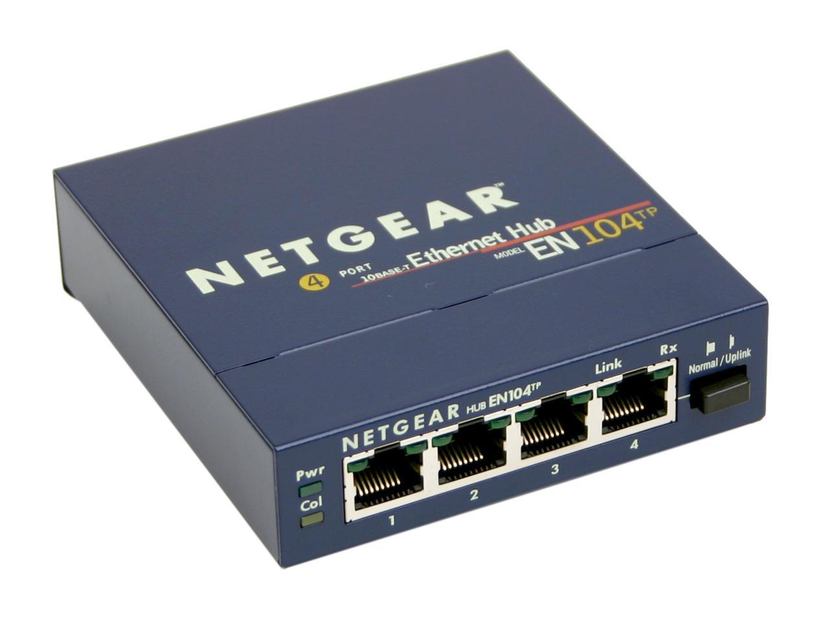

This hub can connect to 4 computers (labelled as 1, 2, 3, 4) with RJ45 cables.

1. RJ45 Jack

This piece of hardware is an 8-pin cable that is used to connect computers/nodes on an ethernet based local area network, also known as LAN. These wires are made of copper.

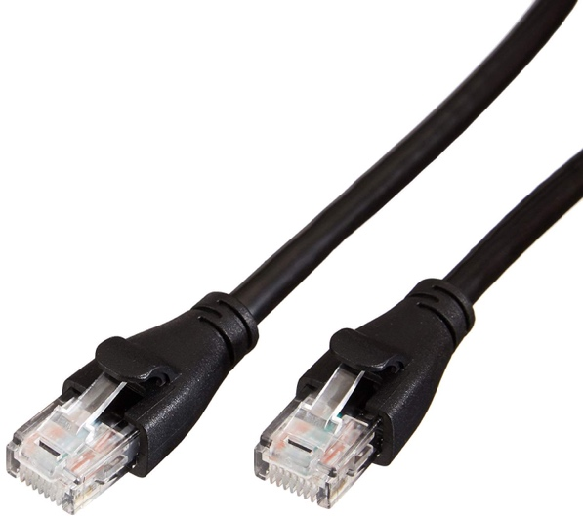

1. LAN Switch

This piece of hardware links locations on a LAN. After a successful connection to a computer by its IP address, the switch will only broadcast data to the computer, instead of to all Lan connected computers.

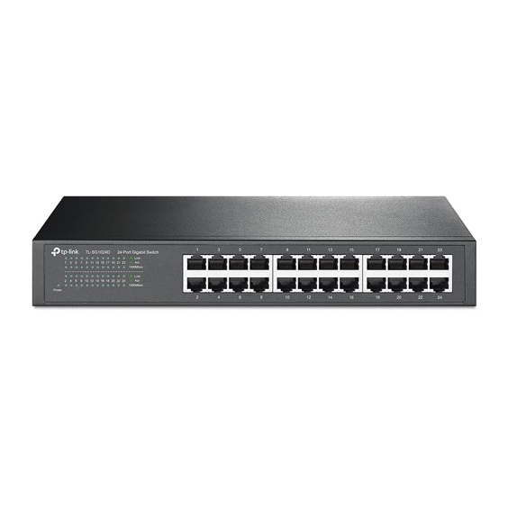

This switch can connect to 24 computers (labelled as 1, 2, 3, …, 24) with RJ45 cables.

1. Router

This piece of hardware links multiple local area networks (LAN), the source and destination may not share the same IP sub address.

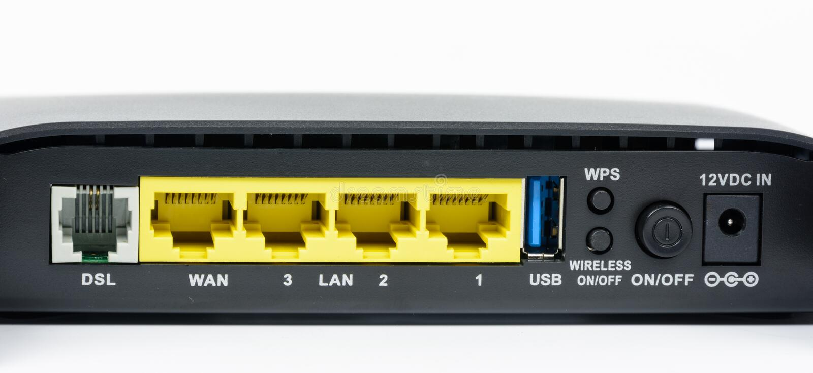

This router can connect to 3 LANs and 1 WAN (wide-area network) with RJ45 cables.

1. Bridge

This piece of hardware is specifically used to connect 2 LANs together, or to connect a LAN to a larger network.

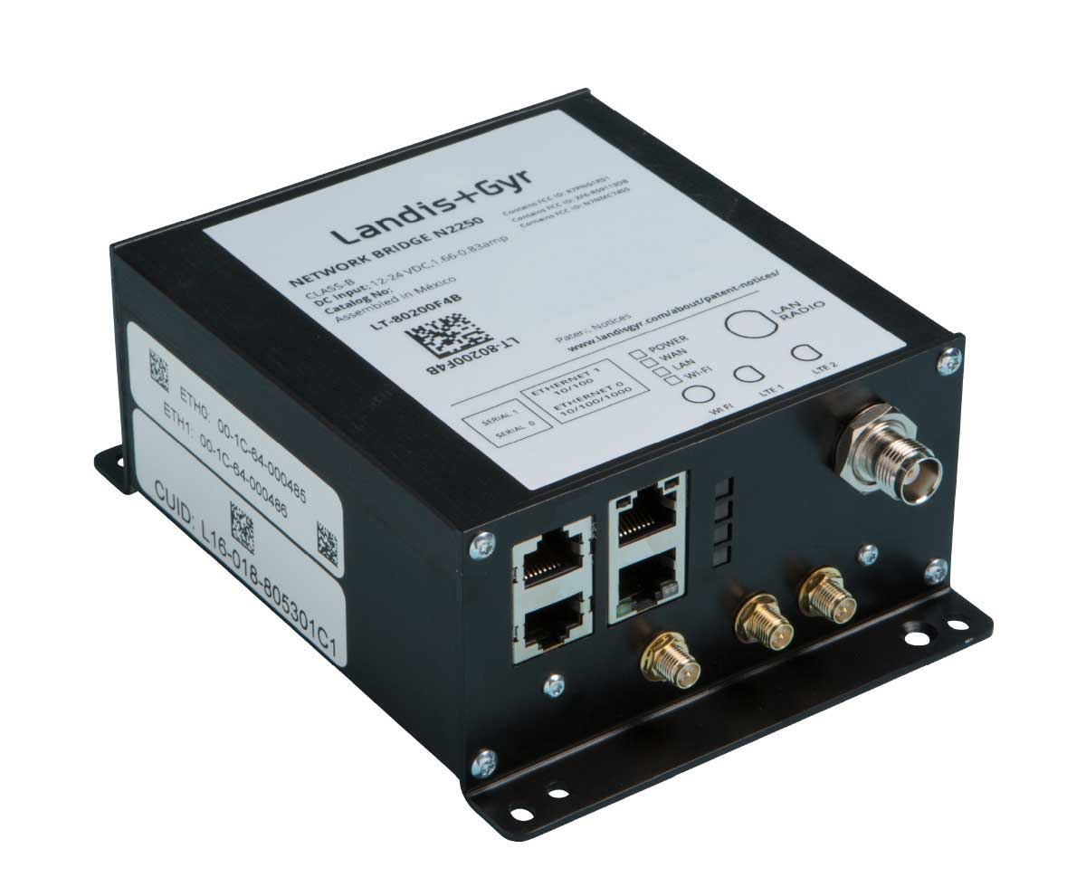

This bridge can connect between 4 different LAN networks.

1. Wireless Access Point

This piece of hardware can convert a physical network to a wireless one, which can connect to wireless devices.

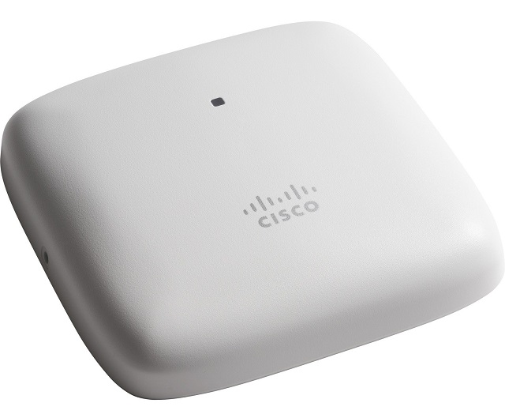

This WAP can connect to multiple wireless devices by giving an input RJ45 cable to connect it to a particular LAN.

1. Modem

This piece of hardware connects you to the internet, essentially connecting you to other servers hosted elsewhere.

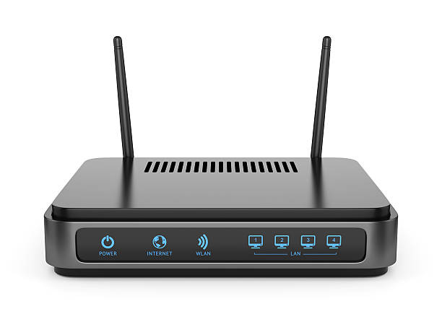

1. Fiber Optic Cable

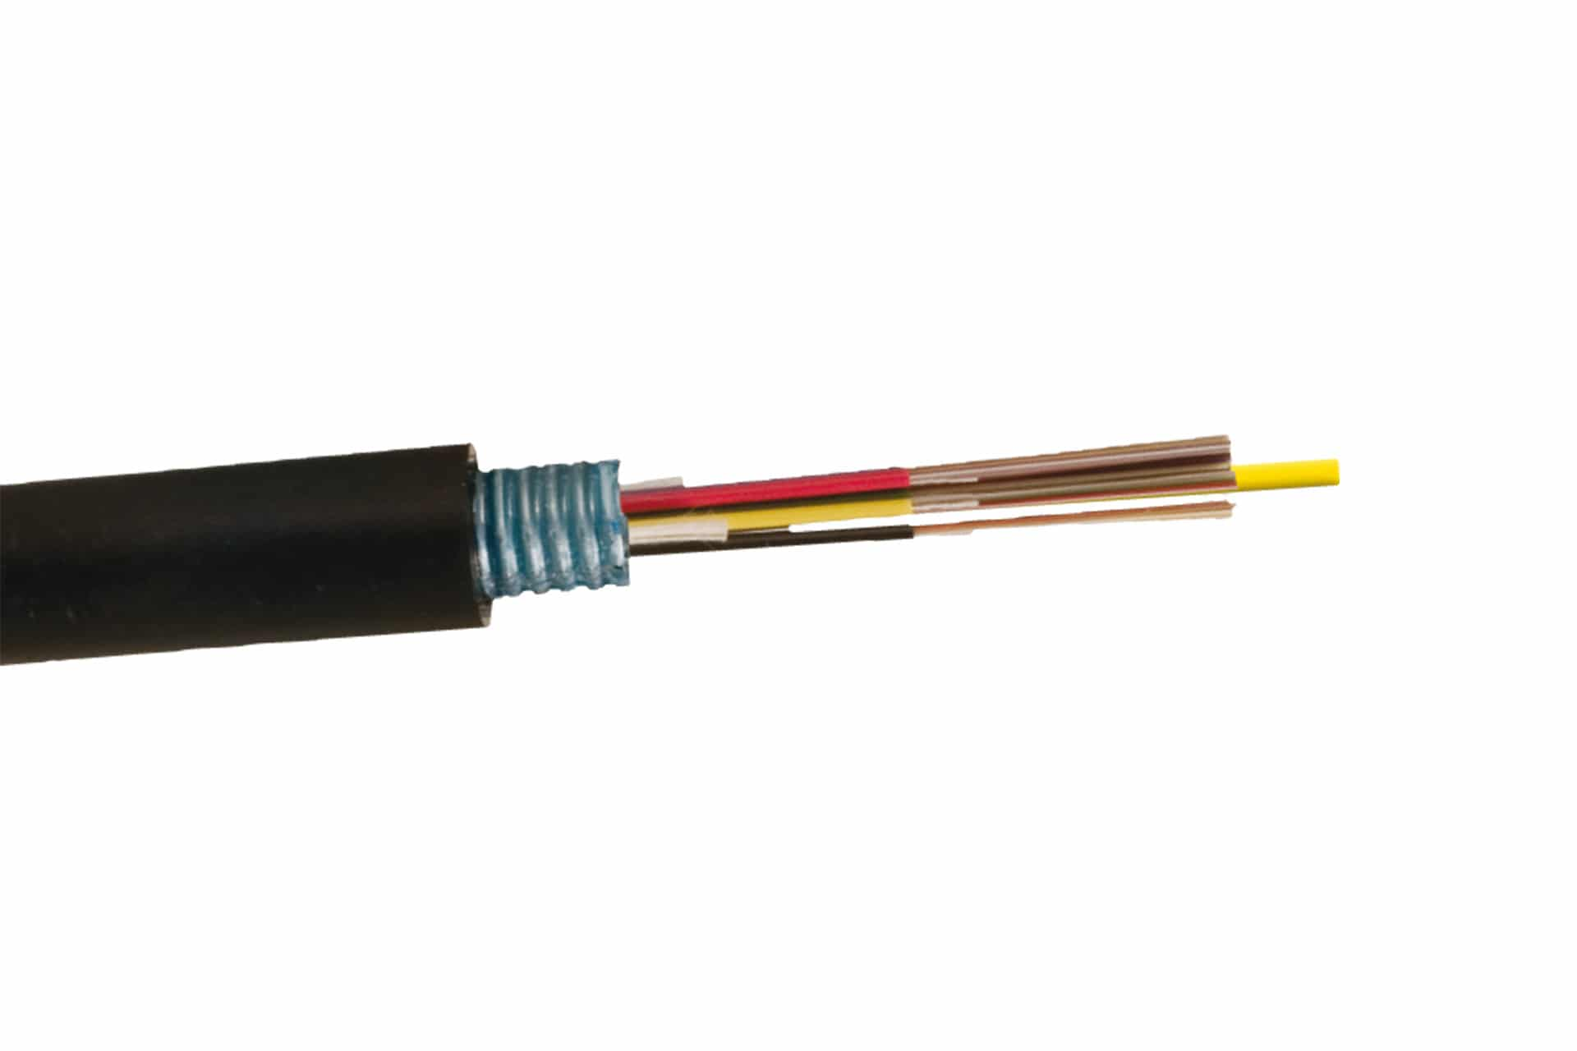This piece of hardware is used for data transmission through the use of light. These cables are to newest addition to networking technology with massively improved speeds compared to copper wires.

1. Repeater

This piece of hardware is used to boost the amplitude/power of a signal, allowing it to travel a further distance and to combat attenuation.



1. Gateway

This piece of hardware sends local traffic to other networks/LANs.

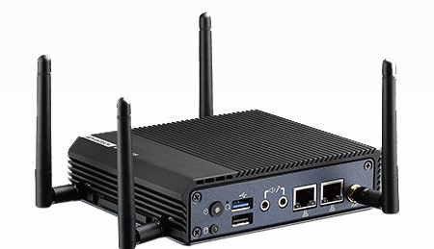

**Question 2**

Byte Stuffing

Code: Python

print('Enter bits, start with frame with f, end frame with e:')

raw = input()

allowed = ['0', '1', 'e', 'f']

# checking for correct format (f has to be starting)

if raw[0] != 'f':

print('Invalid format!')

exit()

# checking for correct formatting (e after f)

e_flag = False

for i in raw:

if i not in allowed:

print('Invalid character!')

break

if e_flag and i == 'f':

e_flag = False

if e_flag and i != 'f':

print('Invalid format!')

exit()

if i == 'e':

e_flag = True

# creating output frame (e before all f and e)

output = ''

for i in raw:

if i == 'e' or i == 'f':

output += 'e' + i

else:

output += i

print('The output frame is:')

print(output)

Input: f010110101ef10101001e

Output: ef010110101eeef10101001ee

Sample Image:

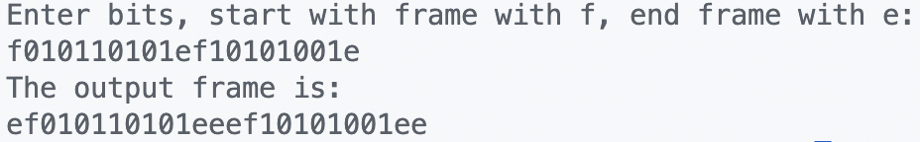

Bit Stuffing

Code: Python

# default flag = 01111110

print('Enter bits:')

raw = input()

allowed = ['0', '1']

# checking for correct formatting (only 0's and 1's)

for i in raw:

if i not in allowed:

print('Invalid format!')

exit()

# creating output frame (stuff 0 after 5 consecutive 1's)

output = ''

count = 0

for i in raw:

output += i

if i == '1':

count += 1

else:

count = 0

if count == 5:

output += '0'

count = 0

print('The output frame is:')

print(output)

# output with the f = 01111110

print('Th output frame with f is:')

print(f'01111110{output}01111110')

Input: 110101111101011111101011111110

Output: 110101111100101111101010111110110

Sample Image:

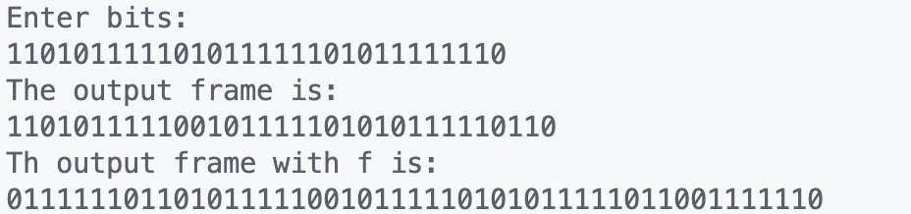

**Question 3**

* ping

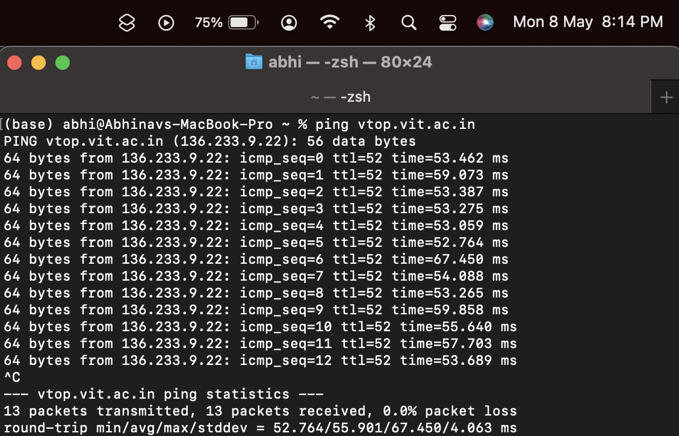

* traceroute

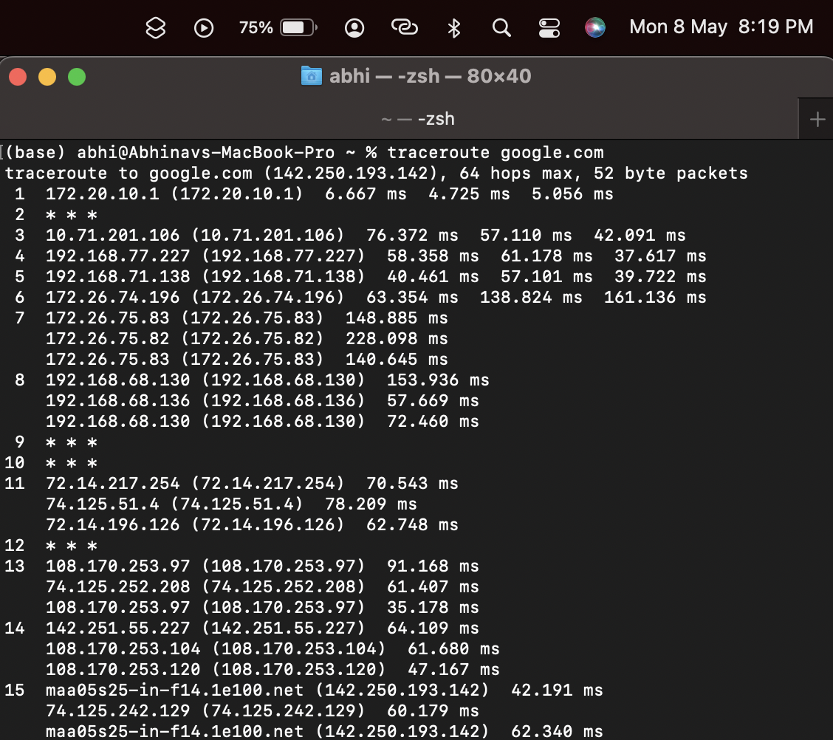

* nslookup

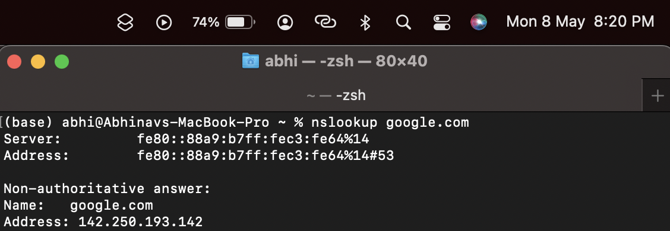

* host

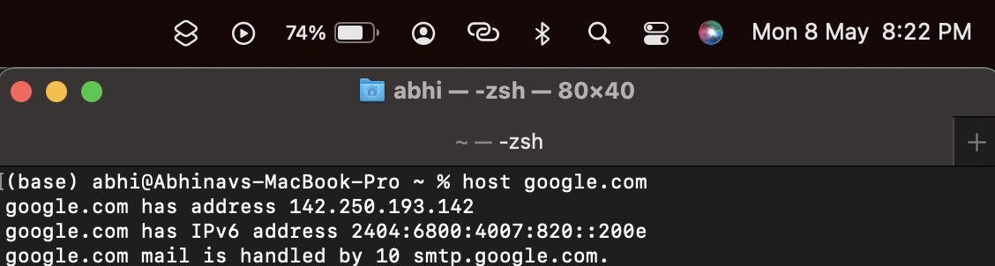

* arp

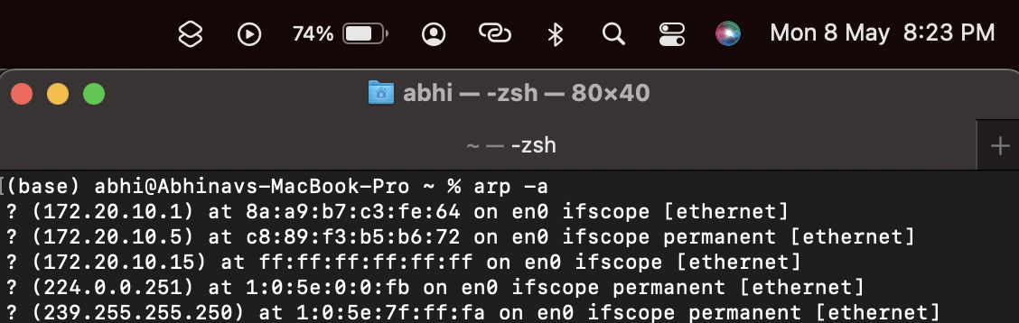

* netstat

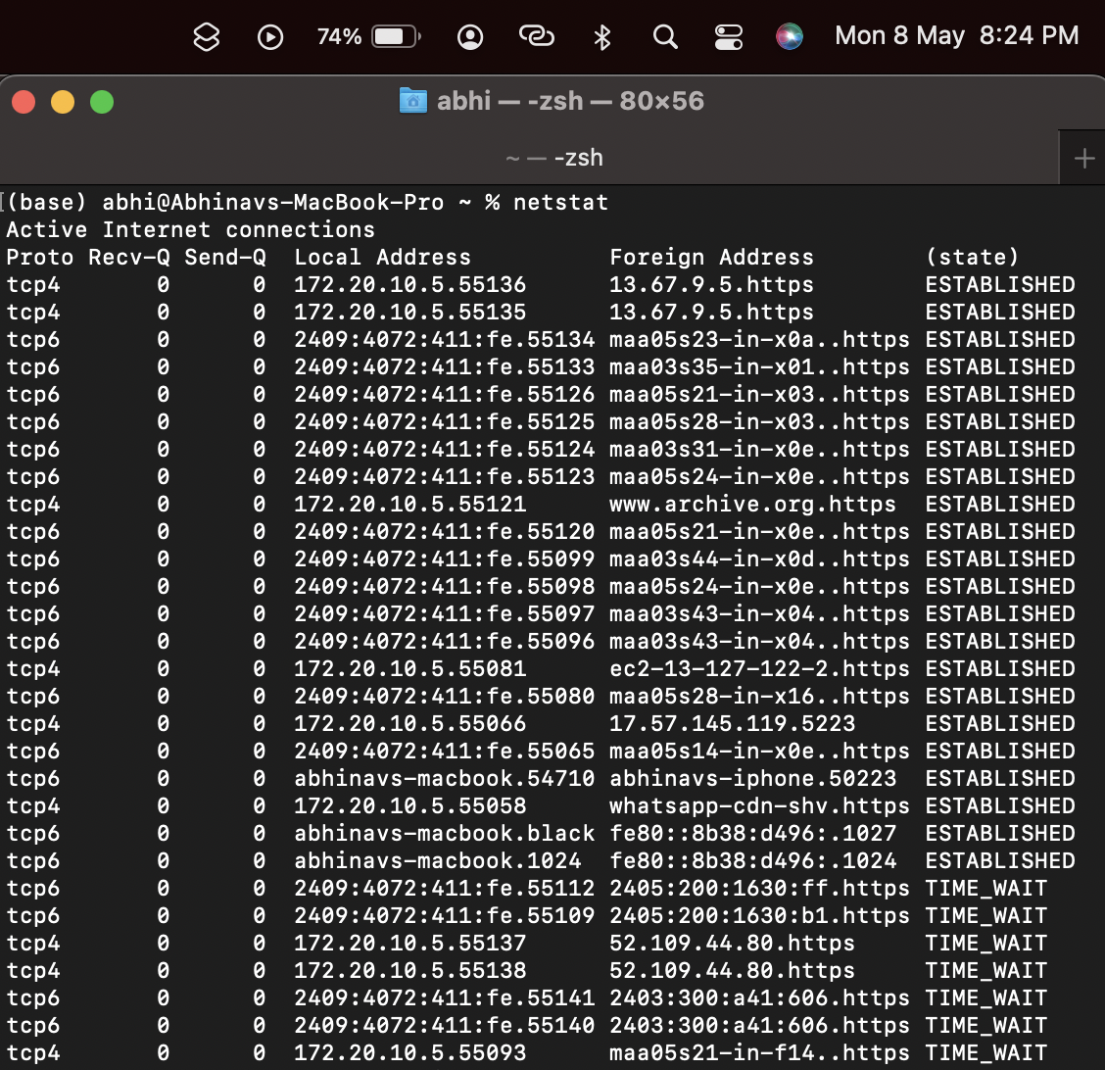

* getmac

